Activity 1.2.3 Circuit Theory - Simulation
Procedure
- Shown below is the schematic for a simple series circuit. Analyze this circuit to determine its total current and the voltage across each of the two resistors. To make these measurements, add an ammeter and two voltmeters. The second schematic shown is the original circuit with the added meters.
Calculated Values:
Using the CDS, enter and simulate this circuit. Measure and record the circuit’s total current and the voltage across each of the resistors.
Measured Values:
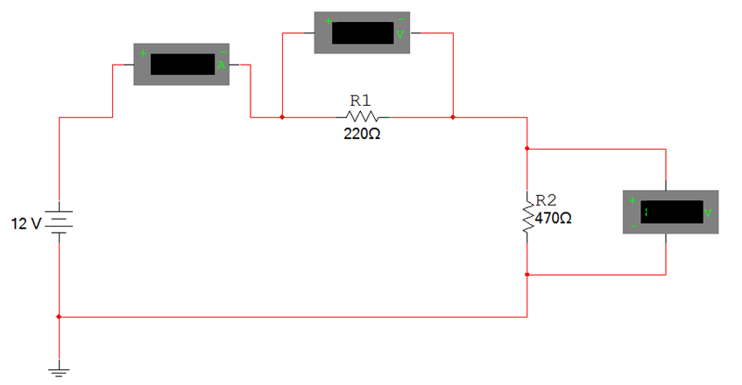
- Using the CDS, analyze the circuit shown below to determine I_{T}, V_{R1}, V_{R2}, & V_{R3}.
Add the appropriate ammeters and voltmeters. Be sure to put your answer in proper engineering notation and use the correct units.
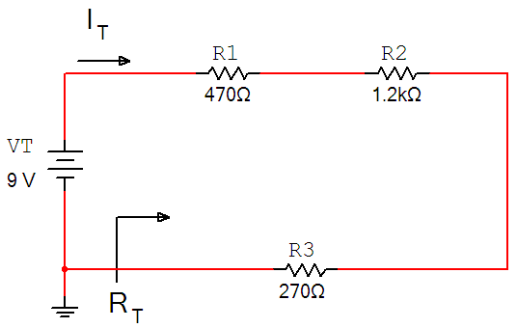
This circuit was analyzed by hand in Activity 1.2.2.
How do these measured values compare to the previously calculated values? If they do not match, review your circuit, your calculations, and make any necessary corrections.

- Using the CDS, analyze the circuit shown below to determine I_{T}, V_{R1}, V_{R2}, V_{R3,} & V_{R4}.
Do the measured values compare to your previously calculate values in Activity 1.2.2?
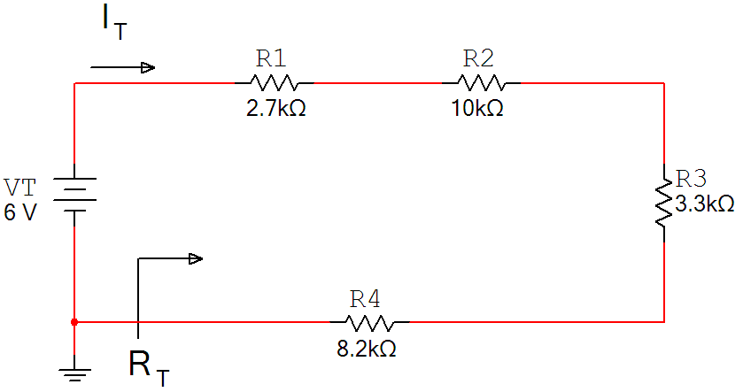

- R Using the CDS, analyze the circuit shown below to determine I_{T}, I_{R1}, I_{R2}, & I_{R3}.
Do the measured values compare to your previously calculate values in Activity 1.2.2?

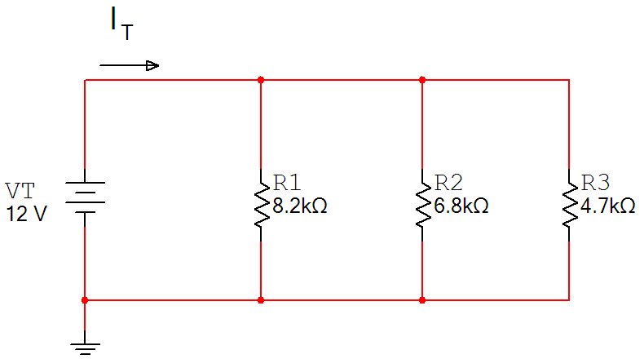

- Using the CDS, analyze the circuit shown below to determine I_{T}, I_{R1}, I_{R2}, I_{R3,} & I_{R4}.
Do the measured values compare to your previously calculate values in Activity 1.2.2?

